Awards
Pageant: 1st – 5th Awards
Individual 1st – 5th Awards
Team/Group: 1st – 5th Awards
Novice: 1st – 5th Awards
NBTA Rules do not allow NOVICE competitors to receive trophies

Novice: won less than 5 – 1st Place Awards
Beginner: won less than 5 – 1st Place Awards
Intermediate: won less than 8 – 1st Place Awards
General Information
1. Absolutely NO HARD Soled SHOES or HEELS on the gym floor.
This includes Participants, Judges, Coaches, Clerks, etc.
Soft sole shoes (Dance/Twirl/Jazz/Athletic) must be worn by participants.
2. Snacks and drinks AVAILABLE ALL DAY. CHICK FIL A BOX LUNCH PRE-ORDERS REQUIRED.

3. No smoking, eating or drinking in the gym unless in specified areas. Will cause disqualification.
4. Any misconduct or use of profane language is prohibited.
5. Facility surcharge: $18.
6. Qualified judges for all events of competition.
7. Tabulation errors must be reported within 30 minutes after close of the contest to be corrected. Thereafter results are FINAL.
8. NO REFUNDS will be given. If potential conflict for High School Football Playoff Game, must be stated on the Registration form.
9. Double entries allowed. Must enter your status level and higher status level
Winning 1st in higher level permanently elevates participant to higher status.
10. No membership fees required, however, NBTA rules will be followed to include NO GYMNASTICS.

On-line entry form at:
https://www.twirlingsweetsensations.org

For information call: (210) 488-1950

Order of Events:
Teams, Modeling, Basic Strut, Presentation, X-Strut, Solo Twirl, Duet/Trio
2-Baton, 3-Baton, Show/Rhythmic Twirl (solo individual music events), IBTF Ratings
All Modeling events, all levels: attire is costume only performed in circle “T” pattern
NO HARD Soled SHOES or HEELS on the gym floor.

Solo and Team Entry Form
CONTEST: Nov 18, 2023 DEADLINE: Oct 31, 2023
No Late Entries Accepted – No Refunds
Teams will perform first!
Set System will be used following all Modeling and Basic Strut Events.
NBTA rules will be in effect. Results will be posted on BAND as tabulation is completed.
NO HARD Soled SHOES or HEELS on the gym floor. All Pageant Modeling events will be in costume.
Contest age is the child’s age as of 9/1/2023
All Entries must be submitted through the link on the TSS Website under Fall Festival:
https://www.twirlingsweetsensations.org

Kick-Off Queen Twirl Pageant ____Beg____Int____Adv____College _____$25.00
Kick-Off Queen Model Pageant _____$15.00
Basic Skills Pageant or Rising Stars Pageant _____$20.00
Best Appearing or Baby Best Appearing _____$9.00

Moms Modeling (name of Mom) _____$9.00
Best Costume _____$9.00
First Contest Basic Strut or Rising Stars Basic Strut _____$9.00

Dad’s Military Strut (name of Dad) _____$9.00
First Contest Solo or Rising Stars Solo _____$9.00
Presentation _____$9.00
Basic Strut & Baby Basic Strut ____Nov____Beg____Int____Adv _____$9.00

Military March ____Nov____Beg____Int____Adv _____$9.00
X-Strut ____Nov____Beg____Int____Adv____College _____$9.00
Solo ____Nov____Beg____Int____Adv____College____Mens _____$9.00
2 Baton ____Nov____Beg____Int____Adv _____$9.00
3 Baton ____Beg____Int____Adv _____$9.00

Show Twirl (Individual Music-CD/IPOD), UIL Routine, IBTF Ratings _____$15.00
Rhythmic Twirl (Individual Music-CD/IPOD) Adv only _____$15.00
Collegiate Twirl (Individual Music-CD/IPOD) _____$15.00

List all Group entries on separate sheet with names, ages and birth dates as of 9/1/15
Duet Twirl (Combined Age) ____0-18____19-24____25-30____31&over _____$15.00
Trio - (Average Age) ____0-10.9 _____ 11-13.9 _____14+ _____$20.00
Twirl Teams, Dance Twirl Teams, Corp Teams and Half-time Show Teams
(4-8) Small _____$25.00 (9-14) Large _____$35.00 (15+) X-Large _____$45.00
Age Groups (As per NBTA Rules): Tiny Tot, Juvenile, Pre-Teen, Junior, Senior, Collegiate
Rating Events
Contestants will perform for the judge for a comment sheet only and will receive a ribbon award.
NO individual music.
Fundamentals _____$5.00
Interview _____$5.00
Best Appearing _____$5.00
Basic Strut ____Nov____Beg____Int____Adv _____$5.00
Military March ____Nov____Beg____Int____Adv _____$5.00
X-Strut ____Nov____Beg____Int____Adv____College _____$5.00
Solo ____Nov____Beg____Int____Adv____College _____$5.00
2 Baton ____Nov____Beg____Int____Adv _____$5.00
3 Baton ____Beg____Int____Adv _____$5.00
Duet/Trio _____$10.00

Money Order/ Cashier checks must be received with Order
Competitive Events Total ___________
Rating Events Total ___________
Additional Sets ($2.00 each) Total ___________
Facility Surcharge & 1 copy of sets (Individual/Family $20) Total ___________

GRAND TOTAL ___________

Payments must be paid on-line with registration.
All entries due by October 31, 2023
NO contestant can perform unless all entry fees are paid.
NO LATE ENTRIES ACCEPTED
Under NO circumstance will late entries be accepted by phone, e-mail or fax.

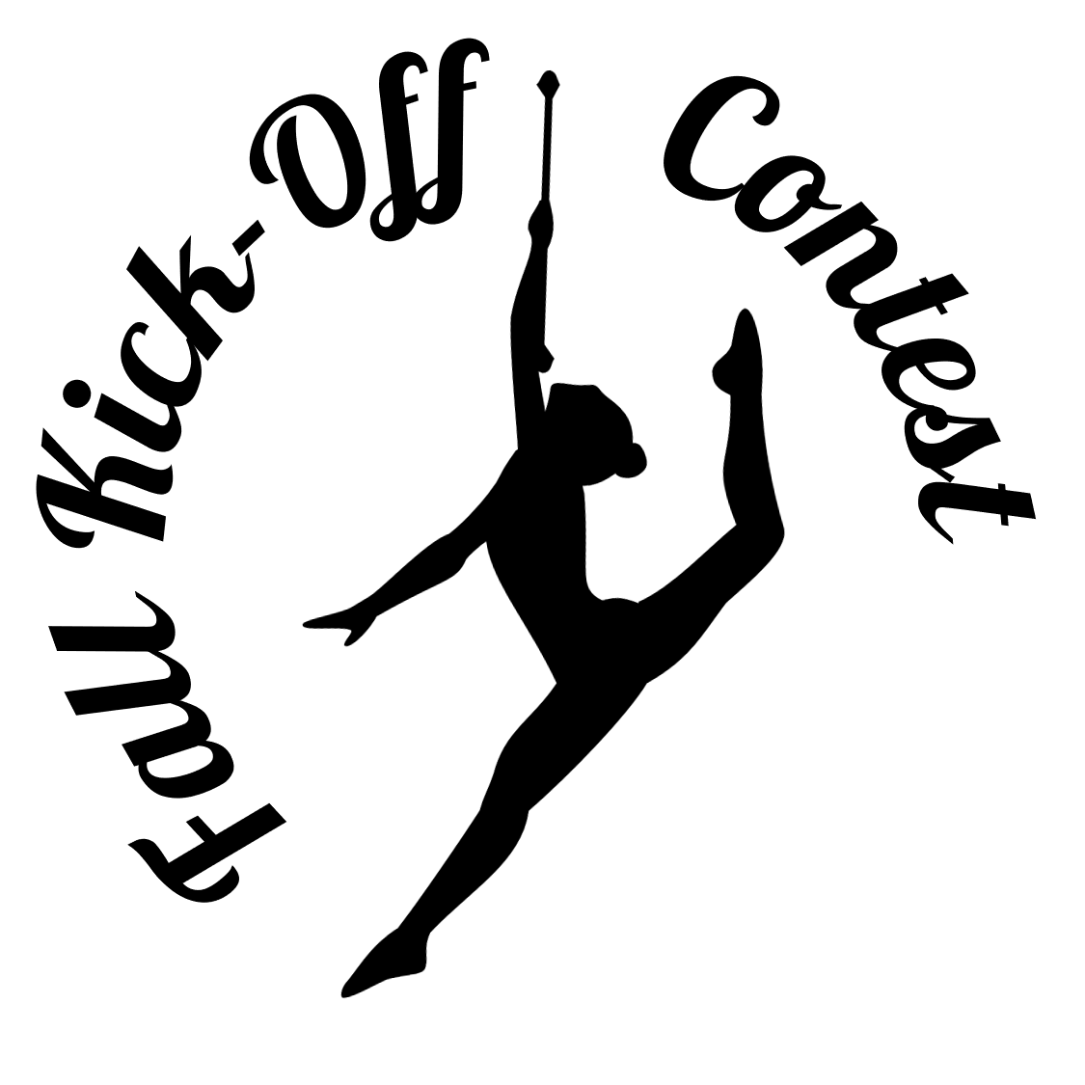
Fall Kick-Off Contest 2023
November 18, 2023
Entry Deadline: Oct 31st
Director: Michele Pangrac
Hosted by: Twirling Sweet Sensations
Fall Kick-Off Contest is held in the spirit of
sportsmanship and to promote our sport of Baton Twirling.
All organizations are welcome, however NBTA Rules will be followed.

Facility Opens: 8:00am
Start Time: 8:30am

Set System will be used following all Modeling and Basic Strut Events.

Location:Randolph AFB High School
6903 S Sunbelt Dr, San Antonio, TX 78218
1225 West Perimeter Rd, Universal City, TX 78108
New location - beautiful gym with bleachers!

*** Special Events ***
Special Division – Rising Stars!!
For contestants with social, physical, developmental or special needs, ONLY.
Pageant and individual events. No scores. All awards!

First Contest – Basic Strut
Competitors who have never competed in a Basic Strut event
First Contest – Solo
Competitors who have never competed in a Solo event

***Mom’s Modeling - Best Appearing
No Interview - Moms dress in their favorite sportswear and model in Circle T Pattern

***Dad’s Military Strut – Military Strut
Dad’s strut their stuff military style with baton in basic strut square

Kick-Off Queen Twirl Pageant
Judged 40% twirling, 40% strut, 20% modeling

Basic Skills Pageant:
Open to Novice twirlers only
Judged 40% basic strut, 40% twirling, 20% modeling in costume
NO INTERVIEW
Kick-Off Queen Model Pageant:
Judged: 60% modeling, 40% interview following NBTA Modeling score sheet
Terrific Turkey Trick Contest (during the lunch break)
For a small donation, twirlers perform their best trick. Each competes by level for the Terrific Turkey Trick Award. (All donations will be given to a food bank to help families in need for the holidays.)

